1.Hypothesis Testing:
ENduku-purpose
To provide supporting information in Decision making.If Null hypothesis is true Mgmt will followit.
Else it rejects Null hypothesis and follows alternate hypothesis.
Decisions will not be solely based on Hypothesis testing resulst.
H0-Null hypothesis
Hu-Alternate hypothesis
We try to prove H0 is true.
EMiti--procedure
Procedure to do Hypothesis testing:
1.Clearly understand data.Understand what has to be used as test statistic.It can be mean,median anythg
2.Come up with clear assumptions.SO that we can realize what confidence interval to use
Like-Data is normally distributed,samples are randomly drawn,variances are equal
3.Formulate Hypothesis:
H0= Bandwidth will be 3gb
Hu=Bandwidht will not be 3gb
4. test statistics explanation
--Distribution of test statistic
Rejection region

Non-rejection region Rejection region

If h0 is true.Values in tails are less likely to occur.
If h0 is false.Values in tails are more likely to occur.
--Decision Rule—
àFail to reject H0

Rejection region
Test statistic

Non-rejection region Rejection

àReject H0
Rejection region

Test Statistics

Non-rejection region Rejection

5.calculate test statistic
6.statistical Decision- to reject H0 or not
7.Conclude if H0 is rejected or not.
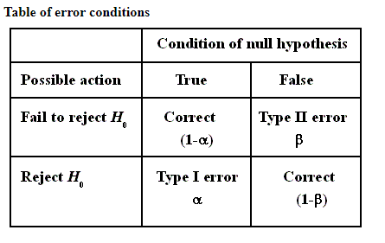
Level of significance
The level of significance, , is a probability and is, in reality, the probability of rejecting a true null hypothesis. For example, with 95% confidence intervals, = .05 meaning that there is a 5% chance that the parameter does not fall within the 95% confidence region. This creates an error and leads to a false conclusion.
Significance and errors
When the computed value of the test statistic falls in the rejection region it is said to be significant. We select a small value of such as .10, .05 or .01 to make the probability of rejecting a true null hypothesis small.
Types of errors
When a true null hypothesis is rejected, it causes a Type I error whose probability is .
When a false null hypothesis is not rejected, it causes a Type II error whose probability is designated by .
A Type I error is considered to be more serious than a Type II error.
Ela—Inference and implementation
Upper-tailed, Lower-tailed, Two-tailed Tests
The research or alternative hypothesis can take one of three forms. An investigator might believe that the parameter has increased, decreased or changed. For example, an investigator might hypothesize:
- H₁: μ > μ ₀ , where μ₀ is the comparator or null value (e.g., μ₀ =191 in our example about weight in men in 2006) and an increase is hypothesized - this type of test is called an upper-tailed test;
- H₁: μ < μ₀ , where a decrease is hypothesized and this is called a lower-tailed test; or
- H₁: μ ≠ μ _{0,} where a difference is hypothesized and this is called a two-tailed test.
The exact form of the research hypothesis depends on the investigator's belief about the parameter of interest and whether it has possibly increased, decreased or is different from the null value. The research hypothesis is set up by the investigator before any data are collected.

Applications:

http://www.mktresearch.org/wiki/Significance_Tests

